1. As mongodb is schemaless and we can have different kinds of documents in the same collection. Thus, it provides us great flexibility which is a huge plus.  
   But sometimes, you want to lock down the your flexibility. Sometimes, you need a strict schema because you know your application is going to fetch posts and it is going to access the title on each post and it expect that each title is a string and for cases like this, schema validation can help you.
2. Now what is schema validation?
3. 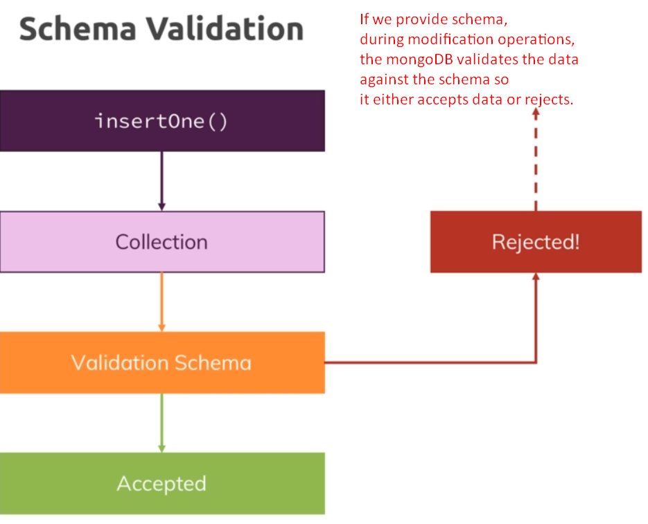
4. We can define schema validation for
   1. What kinds of operations, validation should be performed.
   2. What should happen when validation fails.
5. **Validation Level Strict**: You can set the validation level to strict which means all inserts and updates are checked.
6. **Moderate**: Which means all inserts are checked but updates are only checked for documents which were valid before. So, if you had some invalid data in there because it existed before you set up a schema, then you could still change these documents even if they don’t fit your schema.
7. **Error**: You want to throw an error and don’t want to proceed with insert or update.
8. **Warn**: You want to only log a warning and proceed so then you would still write the data, you will still change the data but log a warning that it didn’t fulfill your criteria.
9. What to choose here, all depend on our app.